GGJ CONSULTANTS AGED CARE RESOURCES – MARCH 2024
For: the strengthened Aged Care Quality Standards
Ph: Les 0407 197 992
Resource | DETAILS | QTY | COST  (GST Ex.) | TOTAL
1. 2024 EXAMPLE POLICIES AND PROCEDURES – HOME CARE
Example Policies and Procedures and Forms for Home Care | Home Care: License for one outlet  Select: CHSP HCP Both – (Click right side of box) |  | $4,500.00
 | License for additional outlets (RACF Numbers) |  | $150.00
 | Annual Support Subscription – Updates for Policies and Procedures (NOT State legislation)* |  | $750.00
 | Support fee per additional outlet |  | $100.00
2. 2024 EXAMPLE POLICIES AND PROCEDURES MANUAL – RESIDENTIAL CARE
Example Policies and Procedures and Forms for Residential Care | Residential Care: License for one outlet |  | $7,000.00
 | License for additional outlets (RACF Numbers) |  | $250.00
 | Annual Support Subscription – Updates for Policies and Procedures (NOT State legislation)* |  | $900.00
 | Support fee per additional outlet |  | $150.00
3. 2024 EXAMPLE POLICIES AND PROCEDURES MANUAL – INTEGRATED HOME CARE AND RESIDENTIAL CARE
Example Policies and Procedures and Forms for Integrated Home Care and Residential Care | Integrated Home Care and Residential Care: License for one outlet.  For Home Care Select: CHSP HCP Both  (Click right side of box) |  | $9000.00
 | License for additional outlets (RACF Numbers) |  | $250.00
 | Annual Support Subscription – Updates for Policies and Procedures (NOT State legislation)* |  | $1200.00
 | Support fee per additional outlet |  | $150.00
4. ADDITIONAL CUSTOMISATION SERVICES FOR EXAMPLE POLICIES AND PROCEDURES MANUALS
Customisation Options for the Policies and Procedures | Inclusion of your logo and service name in the P&P and forms |  | $600.00
 | Change legislation references in the Policies and Procedures to  your State or Territory (Not required for WA - is the default.) (Forms not included) |  | $900.00
 | Updates to State legislation (2 per year. Includes WA) |  | $375.00 Pa
6. 2024 AUDIT AND SURVEY TOOLS: (Requires Microsoft Word and Excel 2007 or newer)
Audit and Survey Tools for Home Care | License for one outlet |  | $900.00
 | License for additional outlets |  | $100.00 each
Audit and Survey Tools for Residential Care | License for one outlet |  | $1,100.00
 | License for additional outlets |  | $100.00 each
Audit and Survey Tools for integrated service | License for one outlet |  | $1,300.00
 | License for additional outlets |  | $100.00 each
7. 2024 NDIS ADD-ON: Inclusion of the NDIS Standards requirements in the Aged Care Policies and Procedures
Covers Module 1 of NDIS Standards | License covers multiple outlets. The Add-on applies to Home Care and Residential Care |  | $3,250.00
8. SERVICE AGREEMENTS
Service Agreement for Home or Residential Care | We recommend the Service Agreement from James Underwood and Associates (Isabelle 07 3229 8955)
Total Ex GST $
TOTAL INCLUDING GST
*Note: If support is not purchased at the time of purchasing your P&P and you wish to purchase it in the future you will need to pay for any periods where payment was not made to receive the updates for those periods. Subscribers also receive our Planning Spreadsheet.

GGJ CONSULTANTS AGED CARE RESOURCES LICENSE AGREEMENT
(Effective @ 20 March 2024)

Organisation: |  | (Required)  ACN/ABN:  Or  Inc. Assoc. No:
Street Address:
Please Indicate: ☐ Approved Provider ☐ CHSP Service Provider only ☐ Consultant ☐ Franchisee
Please Indicate: ☐ Association ☐ Company Limited by Guarantee ☐ Aboriginal Corporation ☐ Pty Ltd Company ☐ LGA
Contact – Policies and Procedures: | Position:
Email: | Ph:
Contact - Invoices: | Position:
Email: | Ph:
EFT: Gevers Goddard-Jones P/L: NAB Fremantle BSB: 086 217 ACCOUNT NO: 54 300 6476
ACCEPTANCE OF LICENSE TERMS AND CONDITIONS
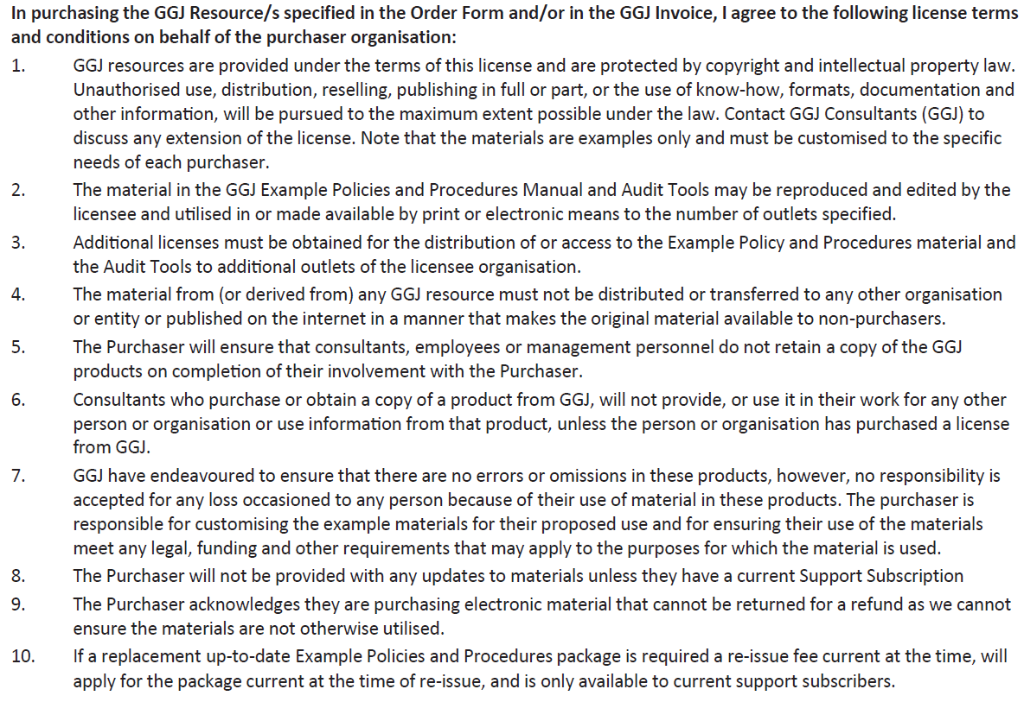
Your Name: | Position:
Signature: | Date:
© 2014-2024 Gevers Goddard Jones Pty Ltd T/A GGJ Consultants ABN: 44 100 066 957
GGJ CONSULTANTS: 0407 197 992 LES@GGJ.COM.AU WWW.GGJ.COM.AU
PO Box 543 North Fremantle WA 6159 | 31 Tuckfield St Fremantle WA 6160

